Abstract title (14 pt)

Name Surname^{1*} , Name Surname ² , Name Surname² , Name Surname² ,...
¹ Address (institution(s), postal address) (9 pt)
² Address (institution(s), postal address) (9 pt)

Please mark in what field is your Abstract (mark with “x” your selection):
Field
Raw materials prospection and discoveries
Mining methods
Geometallurgy and sustainable extraction
Materials recycling and waste management
Education

Please mark do you plan to submit a full paper manuscript Mark your preferred presentation mode:
(mark with “x” your selection):
YES | NO |  |  |  |  | Oral | Poster | No preference

Presenting author:

Keywords: up to 5 terms (separated with “,”)

Abstract

The abstract must not exceed 3 pages. Please keep in mind that the abstract should be concise and informative. Authors must provide clear statements about the research area, the explored surface or subsurface volume(s) in that area, the data sources, quantities, analytical methods, and results (including what was achieved and its significance for readers).
Uncommon abbreviations should be avoided; however, if their use is essential, they must be clearly defined upon their first mention in the abstract.

There are two options to attend the conference with publication:
- send Abstract without the intent to submit a full paper. In this option the review process will start after submission. Abstract will be published in the Book of abstacts,

- send Abstract until deadline with intent to submit full paper. In this option the review process will start after submitting the full paper. Paper will be published in the Proceedings of full papers.

The full papers and abstracts will be published in two separate Proceedings. Authors are allowed to publish on the same topic both as an abstract and as a full paper, provided that the contents are adapted appropriately for each format and intended for two separate publications.

The Authors will be encouraged to transform the Abstract to full paper that can be published in Scopus indexed Journal e.g. Rudarsko-Geološko-Naftni Zbornik.

Each first/corresponding author may submit up to two abstracts and two full papers. There is no limitation on the number of additional contributions as co-author.

Indent each new paragraph by 0.63 cm. Use single-spaced Times New Roman, 10 pt font for the manuscript text
All maps need to be accompanied with (a) graphical scale, (b) geographical coordinates via latitude and longitude, (c) compass rose.
Insert one blank line between the previous paragraph and the top of a figure, table, or equation, as well as between the bottom of an equation or figure/table caption and the following paragraph.

Ensure there are at least two sentences between any headers of different ranks. must be created using Word's table tool (not as bitmaps) and included in the manuscript's .docx file.

Table 1. Text
Xxx | Xxx | Xxx | Xxx | Xxx
Xxx
Xxx
Xxx

Figures and equations

Ensure that all figures and tables are cited in the main text as Figure 1, Table 1, etc. Include figures in the manuscript's .docx file as bitmap images in .jpg or .tiff formats. Editors or reviewers may adjust the placement of figures and tables during the review process. Import high-resolution (at least 300 dpi or 1900x1200 pixels), clear, and readable figures or photos into the .docx file, as they may be resized during formatting. Authors can add their ORCID iD and email address by right-clicking on the ID and email icon below the manuscript title, as shown in Figure 1a. A new dialog box will open (see Figure 1b), where authors can enter their information.

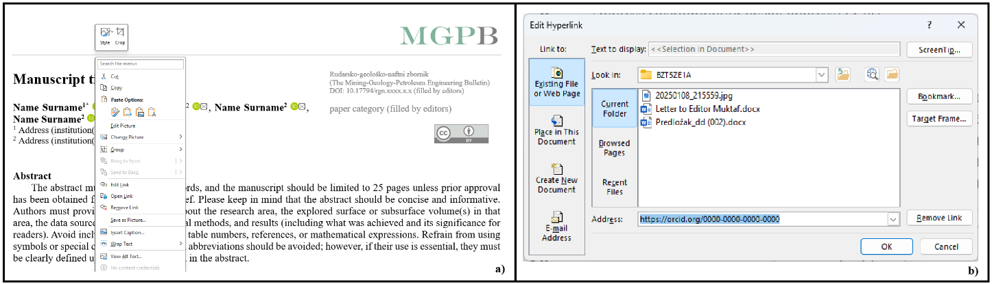
Figure 1. Procedure for Adding an ORCID Number a) Context menu b) Hyperlink dialog

2.1.1. Equations (10 pt)

Here is described calculation (ASTM C97) given in Equations 1 and 2 as follows (for equations the Word Equation editor can be used):

$σ=\frac{F}{A}$ (1)

where are:
F – breaking load (N),
A – surface of the samples (m²),
σ - uniaxial compressive strength (MPa).

$KLA=\frac{m_{0}-m_{1}}{m_{0}} X 100$ (2)

Where are:
KLA - the coefficient of Los Angeles (%),
m_{o} – weight of samples before testing (g),
m₁ - weight of samples which remained on a 2 mm sieve after the testing and sieving (g).

The Word Equation Editor should not be used for symbols that need to be placed directly within the manuscript text. Instead, these symbols should be inserted using Word's Symbol tool. For example, the expression in Equation 2, (m₀ - m₁)/m₀, represents water content.
According to standard rules of writing equations each simbol of physical quantity should be written in italics (except for greek letters) and each measurement unit should not be written in italics (e.g. mass is measured as m=12 kg, not
m= 12 kg or m=12 kg).

All references to publications (citations) in the manuscript should be presented in a list of references (Chillingar et al., 1979; Malvić, 2016a; Malvić, 2016b; Bondarenko et al., 2021; Dolatshahi & Molladavoodi, 2024; URL 1). Blašković et al. (1981) noted that the manuscript should be carefully checked to ensure that the spelling of the authors´ names and dates are exactly the same in the text as in the reference list. DOI must be given at the end of reference where available. The list of references should be arranged alphabetically based on authors´ surname, chronologically. If same authors published with more co-author, alphabetical order is applied on second, third etc. co-author. In the list of references a full name of publication should be used. Citation should follow APA 6 style. We recommend using citation software like Zotero, OneNote, Mendeley etc.

References

ASTM C97 / C97M-09 (2009): Standard Test Methods for Absorption and Bulk Specific Gravity of Dimension Stone, ASTM International, West Conshohocken, PA.
Blašković, I., Tišljar, J., & Velić, J. (1981). Ritmična sedimentacija donjosarmatskih naslaga jugozapadnih obronaka Psunja (Rhythmic sedimentation of Lower Sarmatian deposits on southwestern slopes of Psunj). Nafta: exploration, production, processing, petrochemistry, 32(10), 5-13. (in Croatian).
Bondarenko, V., Kovalevska, I., Cawood, F., Husiev, O., Snihur, V., & Jimu, D. (2021). Development and testing of an algorithm for calculating the load on support of mine workings. Mining of Mineral Deposits. https://doi.org/10.33271/mining15.01.001
Chillingar, G. V., Bissell, H. J., & Wolf, K. H. (1979). The Diagenesis of Carbonate Sediments and Epigenesis (or Catagenesis) of Limestone. Diagenesis in Sediments and Sedimentary Rocks.–Elsevier Publ. Co, 247-422.
Dolatshahi, A. and Molladavoodi, H. (2024). Prediction of rock tensile fracture toughness: hybrid ann-woa model approach. Rudarsko-geološko-naftni zbornik, 39 (3), 1-12. https://doi.org/10.17794/rgn.2024.3.1
Malvić, T. (2016a). Regional turbidites and turbiditic environments developed during Neogene and Quaternary in Croatia. Materials and Geoenvironment, 63(1), 39-54. https://doi.org/10.1515/rmzmag-2016-0004
Malvić, T. (2016b). Ruđer Bošković and the Study of the Earth's Shape. Ruđer Bošković i proučavanje Zemljine građe, Ruđer Bošković i geoznanosti, Lapaine, Miljenko (ed.). Zagreb, Geodetski fakultet Sveučilišta u Zagrebu, Državna geodetska uprava, Hrvatska komora ovlaštenih inženjera geodezije, 165-173.
URL 1. http://www.petteri-teikari.com/pdf/Teikari_LightPollution.pdf (accessed 1st August 2013).

Acknowledgment

Here is place if you wish to thank for any kind of help, financial, technical or other official support and similar.

Funding

If your research received funding, please include the following statement:"This research was funded by [NAME OF FUNDER], grant number [YYY]."

Author’s contribution

Name Surname (academic title): conceptualization, investigation and software. Name Surname (academic title): X and X. Name Surname (academic title): X. Name Surname (academic title): X, X and X…
All authors have read and agreed to the published version of the abstract.

X = conceptualization, data curation, formal analysis, funding acquisition, investigation, methodology, project administration, resources, software, supervision, validation, visualization, writing – original draft and writing – review & editing.

